A Minor Project Report

On

**Online Course registration**

Submitted by:

**161FA04390**

**161FA04358**

**161FA04493**



(ACCREDITED BY **NAAC** WITH **"A"**GRADE)

MHRD**NIRF 88**RANK

**Online Course registration**

**MINOR PROJECT**

**Department of Computer Science & Engineering**

**Vignans Foundation for Science, Technology & Research University, Vadlamudi, Guntur-522213, Andhra Pradesh, India.**

**2017-2018**

**CERTIFICATE**

This is to certify that the minor project report entitled “**Online Course registration**

**:”**

that is being submitted by **161FA04390,161FA04493,161fa04358 in** partial fulfillment for the award of IIyear II semester B.Tech degree in Computer Science and Engineering to Vignan’s Foundation for Science Technology and Research University, is a record of bonafide work carried out by me under the internal guidance of Leela Priya of CSE Department.

Head of the Department

Dr. Venkatesulu D

Professor

Internal Faculty Guide

Leela Priya

Assistant Professor

ABSTRACT

With the advent of Information Technology in the last decade, the major focus has shifted from manual systems to computerised systems.

Various systems viz. railway reservation, hospital management etc. involving manual work have been automated efficiently.

Student course registration process in colleges involve filling registration forms manually, getting it signed by respective subject teachers, and then getting the documents acknowledged from the concerned Advisors, College Deans and Accounts Officers respectively.

Finally the registration forms are submitted in the Administrative Branch. As is evident, this process is very laborious and time consuming.

An Online Student Course Registration System has been developed to simplify the current manual procedure.

This system has been developed using PHP, jQuery, Apache and MySQL.

The front-end is designed using PHP with excerpts of code written using jQuery and back-end is designed and managed through MySQL.

This system software is more secured, user-friendly and less time-consuming

Requirements

Any database system can be chosen as the back-end such as Oracle, MySQL, Microsoft SQL Server, DB2, Access. Any web server can be chosen for the front end such as Tomcat, Glassfish, JRun, etc. Any server side language can be chosen such as PHP, JSP, ASP, etc.

CODES

IMPROVEMENTS

import java.awt.*;

import java.awt.event.*;

import javax.swing.*;

class improvements extends Frame implements ActionListener

{

JFrame f;

JLabel l1,l2;

JTextField t;

List li;

JButton b1,b2;

improvements()

{

f=new JFrame("improvements");

f.getContentPane().setLayout(null);

f.getContentPane().setBackground(Color.white);

l1=new JLabel("course id");

l1.setBounds(50,50,60,30);

l2=new JLabel("Changes");

l2.setBounds(50,80,100,30);

t=new JTextField(10);

t.addActionListener(this);

t.setBounds(110,50,150,30);

li=new List();

li.setBounds(50,110,390,180);

b1=new JButton("Check");

b1.setBackground(Color.yellow);

b1.addActionListener(this);

b1.setBounds(70,300,100,30);

b2=new JButton("Back");

b2.setBackground(Color.yellow);

b2.addActionListener(this);

b2.setBounds(210,300,100,30);

f.getContentPane().add(l1);

f.getContentPane().add(l2);

f.getContentPane().add(t);

f.getContentPane().add(li);

f.getContentPane().add(b1);

f.getContentPane().add(b2);

f.setSize(600,600);

f.setVisible(true);

}

public void actionPerformed(ActionEvent e)

{

if(e.getSource()==b1)

{

}

if(e.getSource()==b2)

{

f.setVisible(false);

new Main();

}

}

public static void main(String args[])

{

new improvements();

}

}

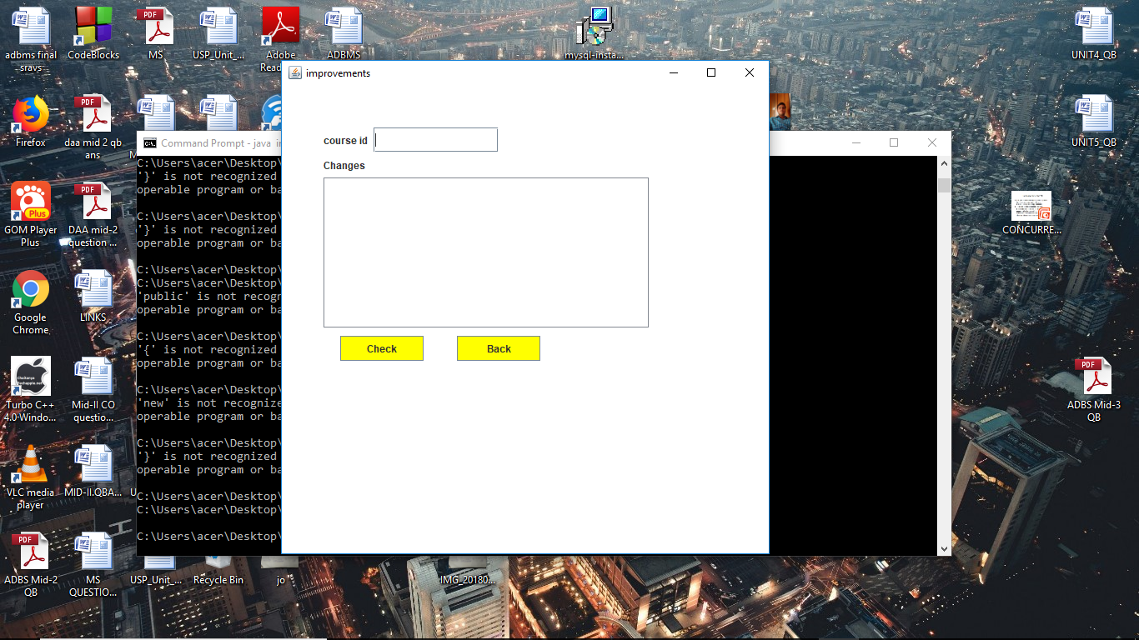

LOGIN

import java.awt.*;

import java.awt.event.*;

import javax.swing.*;

class Login extends Frame implements ActionListener

{

JFrame f;

JLabel l1,l2,l3;

JTextField t,t1,t2;

JButton b1,b2;

Login()

{

f=new JFrame("Course Details");

f.getContentPane().setLayout(null);

f.getContentPane().setBackground(Color.blue);

l1=new JLabel("user name");

l1.setBounds(50,50,100,30);

l2=new JLabel("password");

l2.setBounds(50,80,100,30);

l3=new JLabel("registration date");

l3.setBounds(50,110,100,30);

t=new JTextField(10);

t.addActionListener(this);

t.setBounds(150,50,140,30);

t1=new JTextField(10);

t1.addActionListener(this);

t1.setBounds(150,80,140,30);

t2=new JTextField(10);

t2.addActionListener(this);

t2.setBounds(150,110,140,30);

b1=new JButton("Submit");

b1.setBackground(Color.yellow);

b1.addActionListener(this);

b1.setBounds(70,300,100,30);

b2=new JButton("Back");

b2.setBackground(Color.yellow);

b2.addActionListener(this);

b2.setBounds(210,300,100,30);

f.getContentPane().add(l1);

f.getContentPane().add(l2);

f.getContentPane().add(l3);

f.getContentPane().add(t);

f.getContentPane().add(t1);

f.getContentPane().add(t2);

f.getContentPane().add(b1);

f.getContentPane().add(b2);

f.setSize(600,600);

f.setVisible(true);

}

public void actionPerformed(ActionEvent e)

{

if(e.getSource()==b1)

{

}

if(e.getSource()==b2)

{

f.setVisible(false);

new Main();

}

}

public static void main(String args[])

{

new Login();

}

}

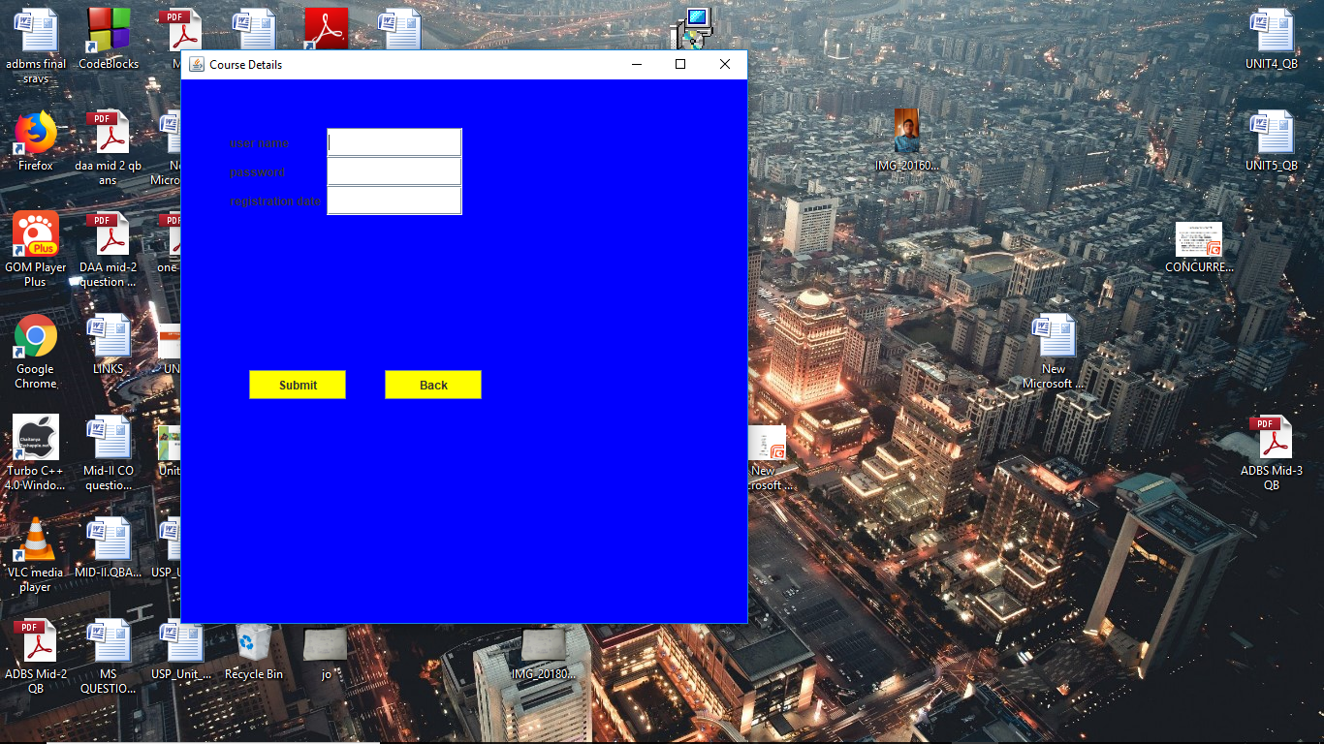

Personal detailes

import java.awt.*;

import java.awt.event.*;

import javax.swing.*;

class Personal extends Frame implements ActionListener

{

JFrame f;

JLabel l1,l2,l3,l4,l5,l6;

JTextField t1,t2,t3,t4;

JButton b1,b2,b3;

Checkbox c1,c2,c3,c4,c5;

CheckboxGroup cbg;

JTextField ta;

Personal()

{

f=new JFrame("Personal");

f.getContentPane().setBackground(Color.green);

l1=new JLabel("course Id");

l1.setBounds(50,50,100,30);

t1=new JTextField(10);

t1.setBounds(170,50,100,30);

l2=new JLabel("Name of student");

l2.setBounds(50,80,120,30);

t2=new JTextField(10);

t2.setBounds(170,80,100,30);

l3=new JLabel("Age");

l3.setBounds(50,130,100,30);

t3=new JTextField(10);

t3.setBounds(150,130,50,30);

l4=new JLabel("Gender");

l4.setBounds(350,130,50,30);

l5=new JLabel("Address");

l5.setBounds(50,170,150,30);

ta=new JTextField(10);

ta.setBounds(150,170,150,30);

l6=new JLabel("Catagory");

l6.setBounds(50,240,100,30);

b1=new JButton("More");

b1.setBackground(Color.yellow);

b1.addActionListener(this);

b1.setBounds(50,330,100,30);

b2=new JButton("Save");

b2.setBackground(Color.yellow);

b2.addActionListener(this);

b2.setBounds(170,330,100,30);

b3=new JButton("Back");

b3.setBackground(Color.yellow);

b3.addActionListener(this);

b3.setBounds(290,330,100,30);

cbg=new CheckboxGroup();

c1=new Checkbox("Male",cbg,true);

c1.setBounds(400,130,100,30);

c2=new Checkbox("Female",cbg,false);

c2.setBounds(400,160,100,30);

c3=new Checkbox("Techer");

c3.setBounds(150,240,100,30);

c4=new Checkbox("Student");

c4.setBounds(150,270,100,30);

c5=new Checkbox("Job Seekers");

c5.setBounds(150,300,100,30);

f.getContentPane().add(l1);

f.getContentPane().add(l2);

f.getContentPane().add(l3);

f.getContentPane().add(l4);

f.getContentPane().add(l5);

f.getContentPane().add(l6);

f.getContentPane().add(t1);

f.getContentPane().add(t2);

f.getContentPane().add(t3);

f.getContentPane().add(ta);

f.getContentPane().add(b1);

f.getContentPane().add(b2);

f.getContentPane().add(b3);

f.getContentPane().add(c1);

f.getContentPane().add(c2);

f.getContentPane().add(c3);

f.getContentPane().add(c4);

f.getContentPane().add(c5);

f.setSize(600,600);

f.setVisible(true);

}

public void actionPerformed(ActionEvent e)

{

if(e.getSource()==b1)

{

}

if(e.getSource()==b2)

{

}

if(e.getSource()==b3)

{

f.setVisible(false);

new Registration();

}

}

public static void main(String args[])

{

new Personal();

}

}

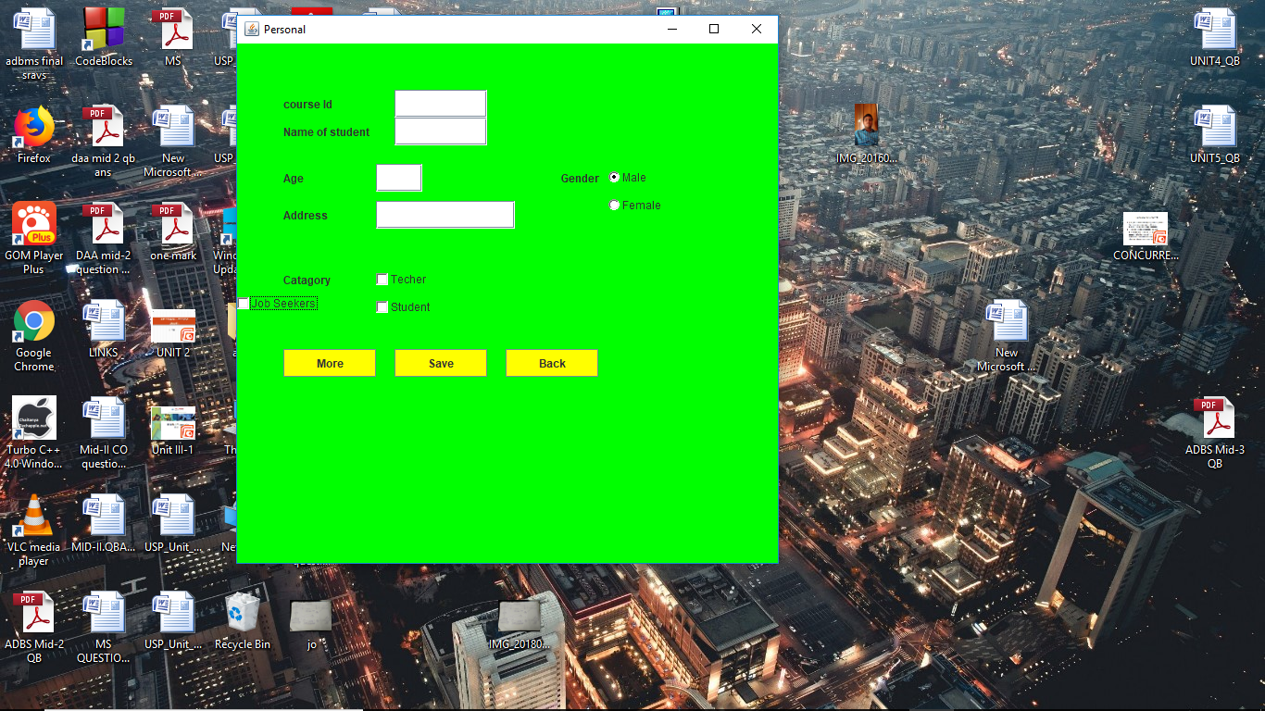

Registration

import java.awt.*;

import java.awt.event.*;

import javax.swing.*;

class Registration extends Frame implements ActionListener

{

JFrame f;

JLabel l1,l2,l3,l4,l5,l6,l7,l8,l9,l10,l11,l12,l13;

JTextField t1,t2,t3,t4,t5,t6,t7;

Choice h;

TextArea ta;

JButton b1,b2,b3;

Registration()

{

f=new JFrame("Registration");

f.getContentPane().setLayout(null);

f.getContentPane().setBackground(Color.orange);

l1=new JLabel("student name");

l1.setBounds(50,50,100,30);

l2=new JLabel("EMAIL ADDRESS");

l2.setBounds(50,80,100,30);

l3=new JLabel("USER NAME");

l3.setBounds(50,110,100,30);

l4=new JLabel("Course");

l4.setBounds(50,140,100,30);

l5=new JLabel("password");

l5.setBounds(50,170,100,30);

l6=new JLabel("RE-enter");

l6.setBounds(50,200,100,30);

l7=new JLabel("btech percentage");

l7.setBounds(250,200,50,30);

l8=new JLabel("Branch");

l8.setBounds(50,230,100,30);

t1=new JTextField(10);

t1.setBounds(150,50,120,30);

t2=new JTextField(10);

t2.setBounds(150,80,100,30);

t3=new JTextField(10);

t3.setBounds(150,110,100,30);

t4=new JTextField(10);

t4.setBounds(150,170,100,30);

t5=new JTextField(10);

t5.setBounds(150,200,100,30);

t6=new JTextField(10);

t6.setBounds(300,200,100,30);

t7=new JTextField(10);

t7.setBounds(150,230,100,30);

h=new Choice();

h.setBounds(150,140,100,30);

h.add("JAVA");

h.add("RUBY");

h.add("C++");

h.add("C");

h.add("HTML");

b1=new JButton("Insert");

b1.setBackground(Color.yellow);

b1.setBounds(50,270,100,30);

b1.addActionListener(this);

b2=new JButton("Next");

b2.setBackground(Color.yellow);

b2.setBounds(160,270,100,30);

b2.addActionListener(this);

b3=new JButton("Main");

b3.setBackground(Color.yellow);

b3.setBounds(270,270,100,30);

b3.addActionListener(this);

f.getContentPane().add(l1);

f.getContentPane().add(l2);

f.getContentPane().add(l3);

f.getContentPane().add(l4);

f.getContentPane().add(l5);

f.getContentPane().add(l6);

f.getContentPane().add(l7);

f.getContentPane().add(l8);

f.getContentPane().add(t1);

f.getContentPane().add(t2);

f.getContentPane().add(t3);

f.getContentPane().add(t4);

f.getContentPane().add(t5);

f.getContentPane().add(t6);

f.getContentPane().add(t7);

f.getContentPane().add(h);

f.getContentPane().add(b1);

f.getContentPane().add(b2);

f.getContentPane().add(b3);

f.setSize(600,600);

f.setVisible(true);

}

public void actionPerformed(ActionEvent e)

{

if(e.getSource()==b1)

{

}

if(e.getSource()==b2)

{

}

if(e.getSource()==b2)

{

f.setVisible(false);

new Personal();

}

if(e.getSource()==b3)

{

f.setVisible(false);

new Main();

}

}

public static void main(String args[])

{

new Registration();

}

}

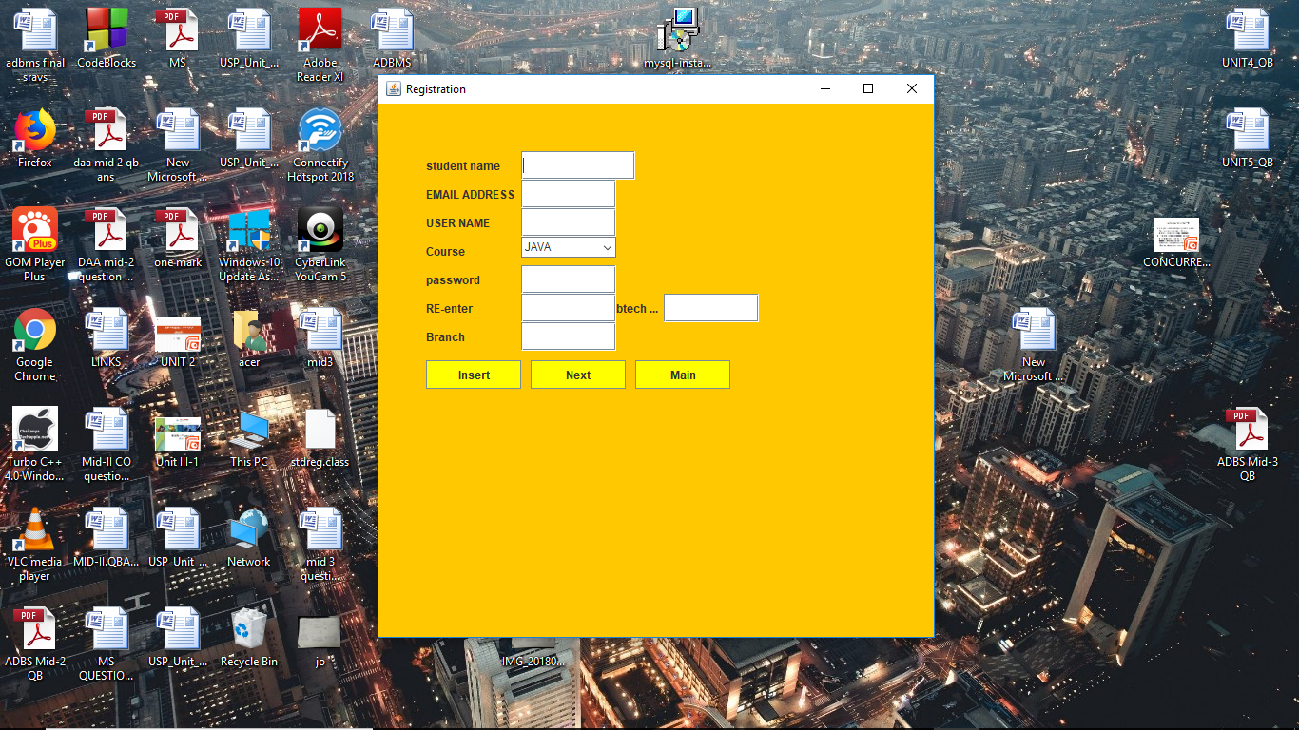

MAIN

import java.awt.*;

import java.awt.event.*;

import javax.swing.*;

class Main extends Frame implements ActionListener

{

JFrame f;

JButton b1,b2,b4,b5;

Registration r;

improvements q;

Cancellation c;

JLabel imgL;

ImageIcon img;

Login nf;

Main()

{

img=new ImageIcon("1483617573-computer-course-banners-top.jpg");

imgL=new JLabel(img);

imgL.setBounds(0,0,1000,800);

f=new JFrame("Main");

b1=new JButton("Registration");

b1.addActionListener(this);

b1.setBounds(240,320,180,40);

b2=new JButton("Rating");

b2.addActionListener(this);

b2.setBounds(470,240,180,40);

b4=new JButton("Exit");

b4.addActionListener(this);

b4.setBounds(680,440,150,40);

b5=new JButton("Login here");

b5.addActionListener(this);

b5.setBounds(240,240,180,40);

f.add(b1);

f.add(b2);

f.add(b4);

f.add(b5);

f.add(imgL);

f.setSize(900,600);

f.setVisible(true);

}

public void actionPerformed(ActionEvent e)

{

if(e.getSource()==b1)

{

f.setVisible(false);

r=new Registration();

}

if(e.getSource()==b2)

{

f.setVisible(false);

q=new improvements();

}

if(e.getSource()==b5)

{

f.setVisible(false);

nf=new Login();

}

if(e.getSource()==b4)

{

f.setVisible(false);

System.exit(0);

}

}

public static void main(String args[])

{

new Main();

}

}

